UPDATE obat

SET harga = '10000'

WHERE id = '10';

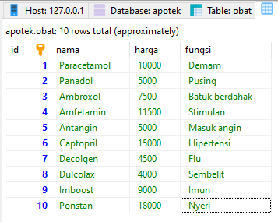

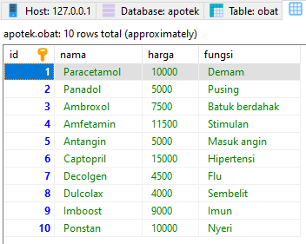

UPDATE stok

SET stok = '30'

WHERE id = '9';

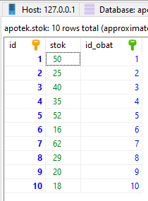

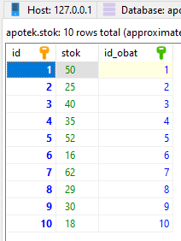

UPDATE transaksi

SET jumlah_transaksi = '7'

WHERE id = '2';

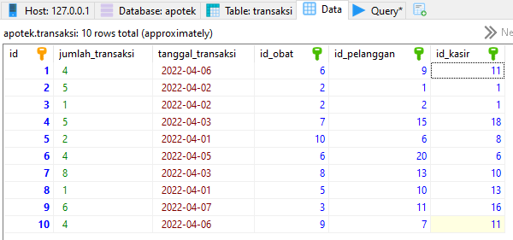

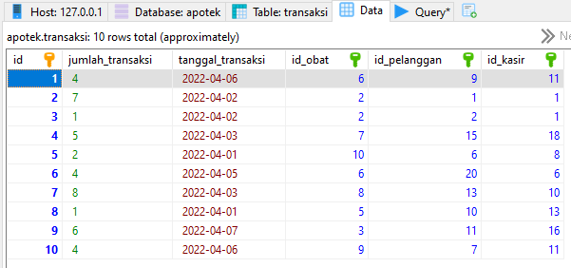

DELETE FROM pelanggan WHERE id = '19';

DELETE FROM pelanggan WHERE nama = 'Putra';

